Bee-ing Our Best at Home!
Behavior Matrix
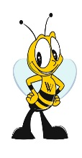  GOALS | All Settings | Getting up in the morning  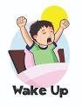 | School Time | While adults are working  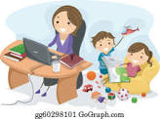 | Bathrooms | Mealtime  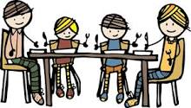 | 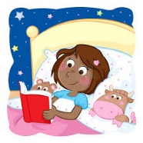  Bedtime
BE  SAFE  (Safety) | Follow adult directions  Wash your hands |  |  |  | Wash your hands with soap and water
BE
RESPONSIBLE

(Ownership/
Accountability)
BE
RESPECTFUL

(Respect)

