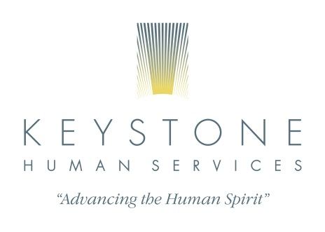
April 29, 2020
The following agencies take Gateway Insurance and have staff that work with loss and grief. Dauphin County CMU can assist with waiting lists and scheduling if that would help the family.

Alcove Counseling Center Franklin Family Services
1150 Lancaster Blvd. 20 Briarcrest Square
Mechanicsburg, PA 17055 Hershey, PA 17033
717-691-1090 717-533-4312

PA Counseling PA Psychiatric Institute
200 South Progress Ave. 2501 North 3rd Street
Harrisburg, PA 17109 Harrisburg, PA 17110
717-526-4889 717-782-2160

Pinnacle Health Psychological Assoc. Riverside Associates
205 S. Front St. 2818 Green Street
Harrisburg, PA 17104 Harrisburg, PA 17110
717-231-8360 717-238-6880

Mountain View Counseling Dauphin County Case Management (CMU)
3544 North Progress Ave. 1100 South Cameron Street
Harrisburg, PA 17110 Harrisburg, PA 17104
717-537-9569 717-232-8761

Catholic Charities – Capital Region Counseling Jewish Family Services
939 East Park Drive 3333 North Front Street
Harrisburg, PA 17111 Harrisburg, PA 17110
717-233-7978 717-233-1681

Highmark Caring Place – NO FEE FOR SERVICE
3 Walnut Street
Lemoyne, PA 17043
717-302-8411

